Final ESG Generated-vs-Actual Analysis
Integrated synthesis of Python text metrics and LLM-style qualitative analysis

Executive Summary
The DataNXT-generated ESG reports reproduce the broad ESG structure of the official benchmark reports, but they are much shorter and more standardized. The official reports remain stronger as audit-ready disclosure documents because they contain more quantified evidence, reporting-boundary detail, framework language, and company-specific risk information.
- Closest generated-vs-actual vocabulary match: Microsoft with TF-IDF cosine similarity of 0.2954.
- Lowest generated-vs-actual vocabulary match: SAP with TF-IDF cosine similarity of 0.2473.
- Across all four companies, generated reports are compact summaries rather than substitutes for official ESG or annual-report disclosures.
- The strongest qualitative limitation is not direct contradiction, but missing depth: official reports include disclosure boundaries, assurance language, materiality framing, tables, and operational metrics that generated reports compress.

Data and Source Basis
Company | Generated source | Actual benchmark source
Amazon | Amazon_ESG_Report_Generated.docx | 2024 Amazon Sustainability Report - 2024-amazon-sustainability-report.pdf
Microsoft | Microsoft_ESG_Report_Generated.docx | microsoft_2025_environmental_sustainability_report.pdf; microsoft_2025_impact_summary.pdf
SAP | SAP_ESG_Report_Generated.docx | SAP 2025 Annual Report Form 20-F.html
Zalando | Zalando_ESG_Report_Generated.docx | zalando-se_en_full-csrd-esrs-report_annual-report_2025.pdf

Python Analysis Findings
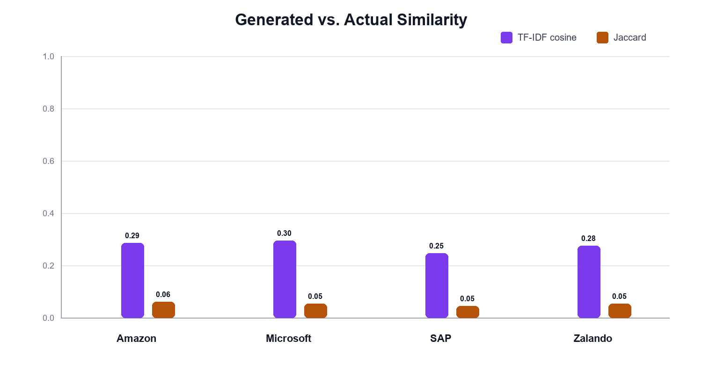
Figure 1. Similarity between generated and official benchmark reports.
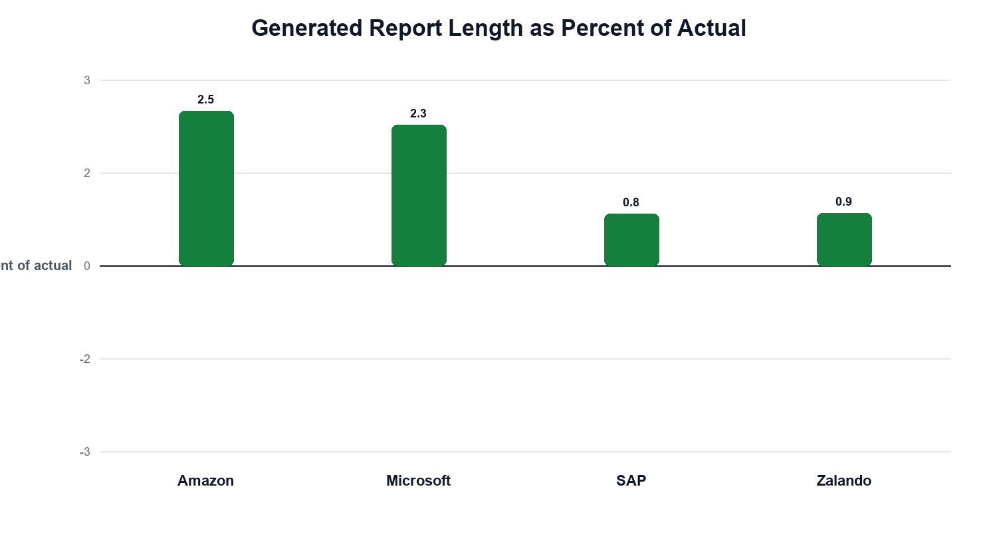
Figure 2. Generated report length as a percentage of actual report length.
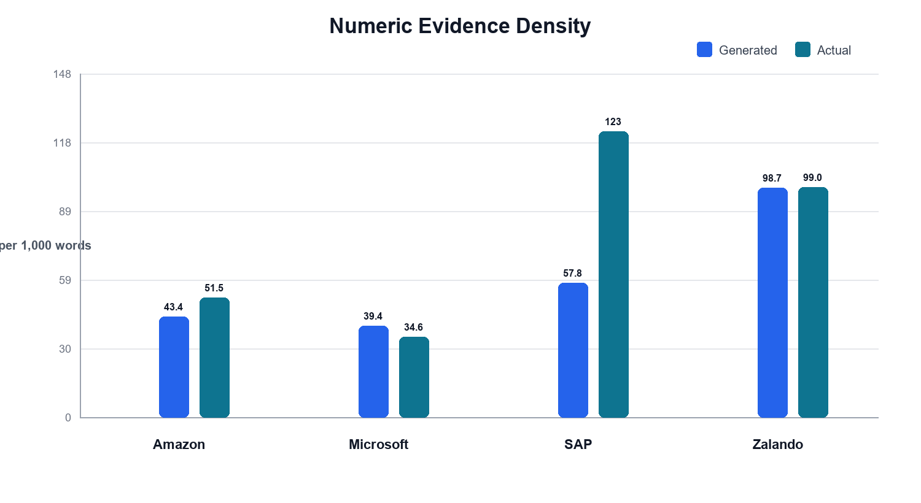
Figure 3. Numeric evidence density in generated and actual reports.
The similarity scores are modest across all companies. This is expected because official reports are much longer and contain large sections of regulatory, financial, assurance, and framework-specific disclosure language. Jaccard similarity is especially low because it compares cleaned vocabulary set overlap and is sensitive to the much broader vocabulary in actual reports.
Company | TF-IDF cosine | Jaccard | Generated length as % of actual | Numeric density gap
Amazon | 0.2873 | 0.0615 | 2.51 | -8.09
Microsoft | 0.2954 | 0.0542 | 2.29 | 4.81
SAP | 0.2473 | 0.0455 | 0.84 | -65.29
Zalando | 0.2766 | 0.0548 | 0.86 | -0.35

ESG Coverage and Tone
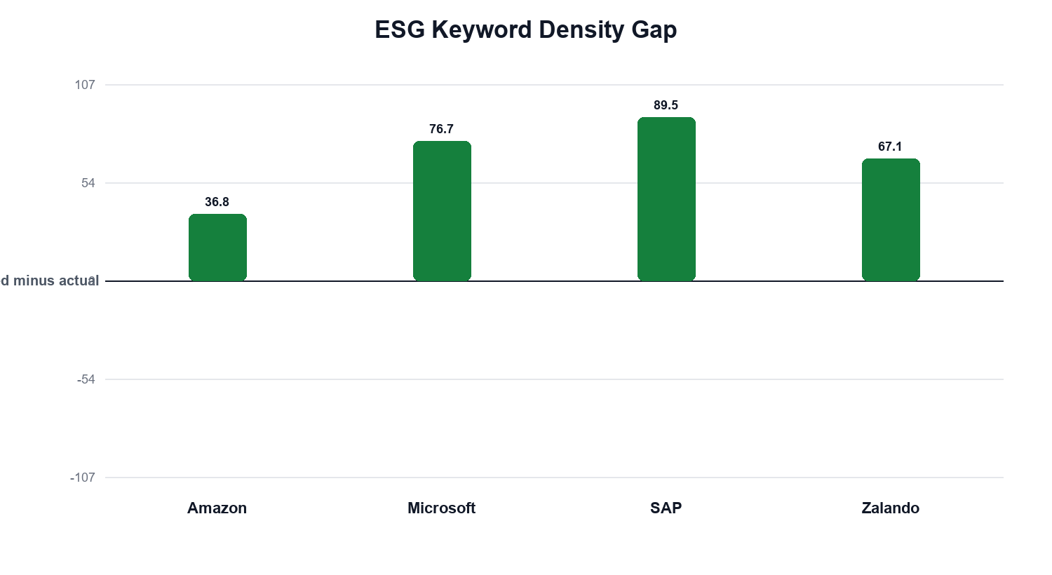
Figure 4. ESG keyword-density gap: generated minus actual.
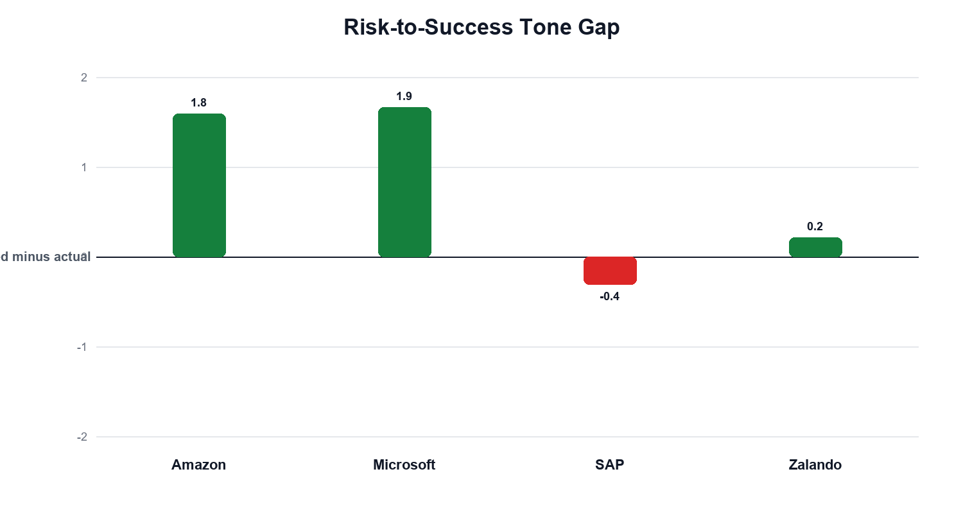
Figure 5. Risk-to-success tone gap: generated minus actual.
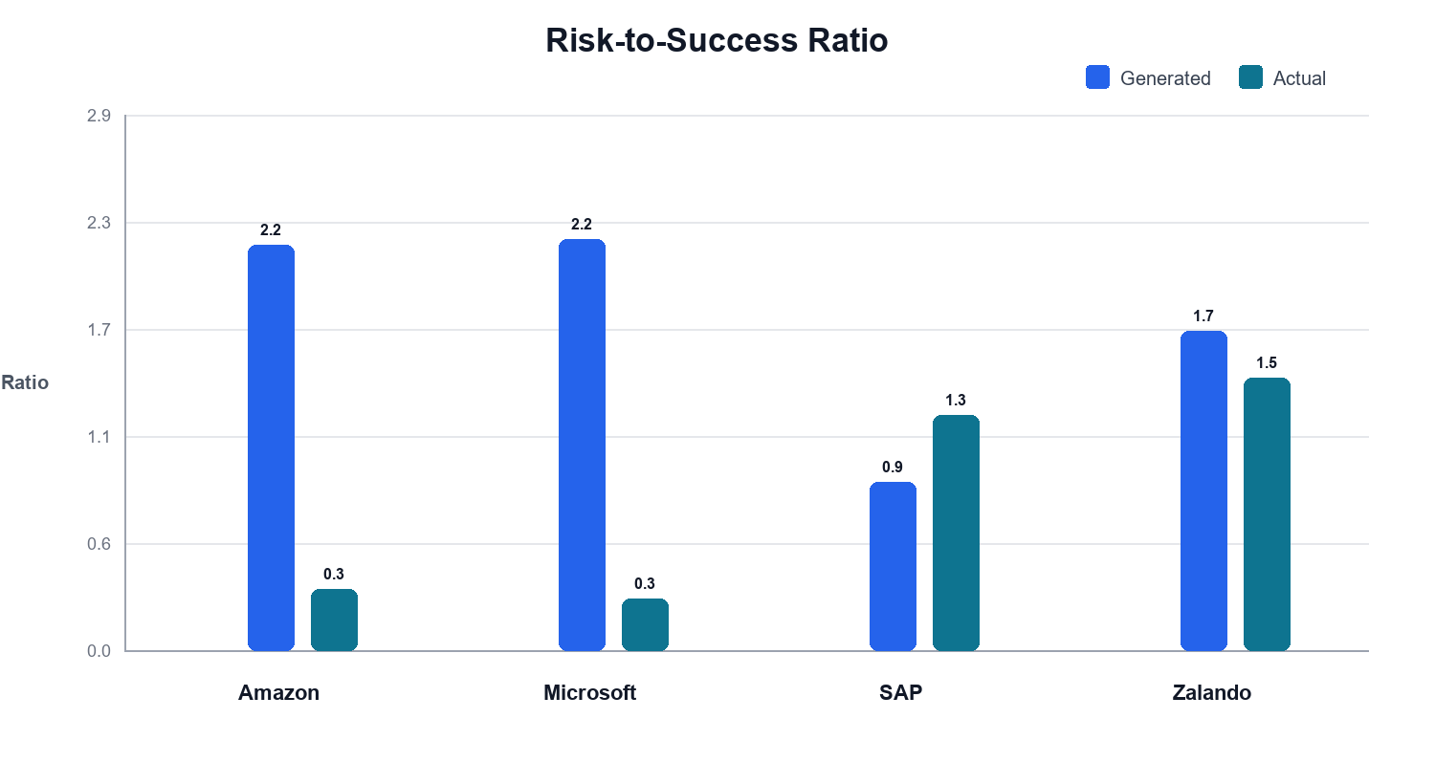
Figure 6. Risk-to-success tone ratios in generated and actual reports.
The generated reports often show high ESG keyword density because they are short and deliberately structured around E, S, and G headings. This does not mean they have more evidence. It means ESG vocabulary is more concentrated. Official reports spread ESG content across broader financial, governance, assurance, and operational disclosure sections.

LLM-Style Qualitative Synthesis
- Factual contradictions: no clear direct contradiction was detected from the generated-vs-actual comparison. The main issue is compression and missing context.
- Missing themes: generated reports underrepresent official framework language, assurance boundaries, table-based indicators, regional or segment detail, and formal materiality language.
- Specificity: generated reports sometimes have high numeric density per 1,000 words, but official reports contain far more total quantified evidence and better audit trails.
- Tone: generated reports tend to be more normalized and balanced; official reports include more granular risk, target, assurance, and compliance language.

Company-Level Interpretation

Amazon
The generated Amazon report captures climate, logistics, workforce, and governance themes, but the official sustainability report contains more operational detail across emissions, packaging, suppliers, safety, and program-level metrics.
Key metrics: TF-IDF cosine 0.2873; Jaccard 0.0615; generated length 2.51% of actual.

Microsoft
The generated Microsoft report is close in broad topic framing but much shorter than the official environmental and impact reports, which provide more detailed cloud, AI, water, energy, and social-impact evidence.
Key metrics: TF-IDF cosine 0.2954; Jaccard 0.0542; generated length 2.29% of actual.

SAP
The SAP comparison now uses the official SAP 2025 Annual Report Form 20-F as a full benchmark after the original 5-page local PDF proved incomplete. The generated report captures governance-heavy framing, while the official filing contains much deeper regulatory, financial, risk, and reporting-boundary language.
Key metrics: TF-IDF cosine 0.2473; Jaccard 0.0455; generated length 0.84% of actual.

Zalando
The generated Zalando report captures fashion-specific ESG issues such as suppliers, returns, circularity, and platform governance, but the official CSRD/ESRS report is far more granular and framework-specific.
Key metrics: TF-IDF cosine 0.2766; Jaccard 0.0548; generated length 0.86% of actual.

Economic Intuition
ESG disclosure is not only a communication exercise. It is a governance and accountability mechanism shaped by regulation, assurance expectations, stakeholder pressure, and sector-specific risk. A reusable AI workflow can standardize report structure and produce comparable ESG summaries, but official reporting remains richer because it must define reporting boundaries, disclose material impacts, and support claims with auditable evidence.

Critical Reflection
- PDF and HTML extraction can miss layout, table structure, footnotes, graphics, and some disclosure context.
- Keyword analysis is transparent and reproducible, but it cannot fully judge factual correctness or materiality.
- Similarity metrics are influenced by document length, boilerplate, and reporting-framework vocabulary.
- The generated reports should be treated as structured ESG summaries, not as replacements for official reports.
- The final project conclusion should emphasize both the usefulness of AI-assisted drafting and the need for human validation against official disclosures.

Source Note
The SAP Integrated Report 2025 PDF is officially listed on SAP Investor Relations, but SAP's CDN blocked direct local shell download in this environment. For the reproducible local comparison, SAP's official SEC filing, SAP 2025 Annual Report Form 20-F, was added as the full actual benchmark source.

